**NAME:** SREYA G **REGISTER NO.:**230701334

**CLASS:** CSE F **DATE:** 29/08/2024

**EX - 4:**

**DIVIDE AND CONQUER:**

PROBLEM 1:

AIM:

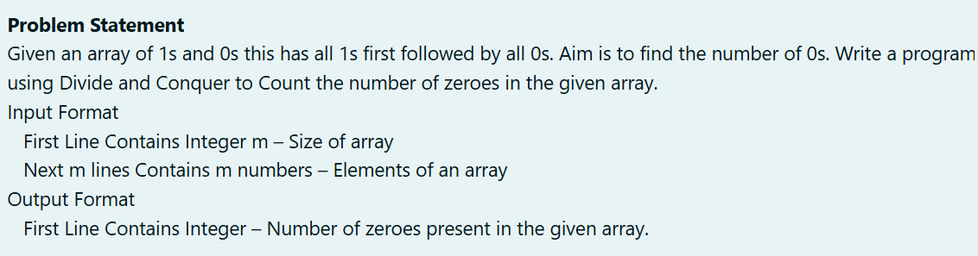

ALGORITHM:

1. Input the array size (n) and the array elements.

2. Initialize a counter (c) to 0 for storing the count of zeros.

3. Define a recursive function (find):

- If the leftmost element of the current segment is 0:

- Increment c by the number of elements in the segment.

- Otherwise, divide the segment into two halves and recurse.

4. Call find on the full array(left = 0, right = n - 1).

5. Output the counter (c).

CODE:

#include<stdio.h>

int c = 0;

void find(int a[],int left,int right)

{

if(a[left] == 0)

{

c += (right-left+1);

}

else

{

if(left < right)

{

int m = (left + right)/2;

find(a,left,m);

find(a,m+1,right);

}

}

}

int main()

{

int n;

scanf("%d",&n);

int a[n];

for(int i = 0;i < n;i++)

{

scanf("%d",&a[i]);

}

find(a,0,n - 1);

printf("%d",c);

}

OUTPUT:

RESULT:

Thus the code is executed successfully and gives the expected output.

PROBLEM 2:

AIM:

ALGORITHM:

1. Input nums (size) and array arr.

2. Initialize counter c = 0.

3. Recursive Function C(a, l, r, k):

- Count occurrences of k in a[l:r].

4. Set b = arr[0] as the candidate element.

5. If C(arr, 0, nums, b) > nums/2, print b.

6. Else, check first half for a different element and print b.

CODE:

#include<stdio.h>

int c = 0;

int C(int a[],int l,int r,int k)

{

int m = l+(r-l)/2;

if(a[m] == k)

{

c++;

}

else

{

C(a,l,m,k);

C(a,m+1,r,k);

}

return c;

}

int main()

{

int nums;

scanf("%d",&nums);

int arr[nums];

for(int i = 0;i < nums;i++)

{

scanf("%d",&arr[i]);

}

int b = arr[0];

if(C(arr,0,nums,b) > nums/2)

{

printf("%d",b);

}

else

{

for(int i = 0;i < nums/2;i++)

{

if(arr[i] != b)

{

printf("%d",b);

break;

}

}

}

}

OUTPUT:

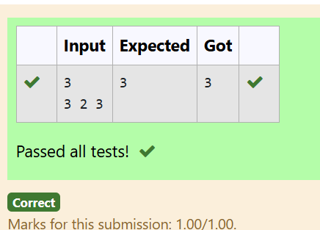

RESULT:

Thus the code is executed successfully and gives the expected output.

PROBLEM 3:

AIM:

ALGORITHM:

1. Input n (size) and array a[].

2. Input divisor.

3. Define recursive function maxfloor(a, left, right, divisor):

- Calculate the middle index mid.

- If a[mid] divided by divisor is 0 and greater than highest, update highest.

- Recursively check the left and right segments.

4. Call maxfloor(a, 0, n, divisor)

5. Output the value of highest.

CODE:

#include<stdio.h>

int highest = 0;

int maxfloor(int a[], int left, int right,int divisor)

{

if(left < right)

{

int mid = (left+right-1)/2;

if(a[mid]/divisor == 0 && highest < a[mid])

{

highest = a[mid];

}

maxfloor(a,left,mid,divisor);

maxfloor(a,mid+1,right,divisor);

}

return highest;

}

int main()

{

int n;

scanf("%d",&n);

int a[n];

for(int i = 0;i < n;i++)

{

scanf("%d",&a[i]);

}

int divisor;

scanf("%d",&divisor);

printf("%d",maxfloor(a,0,n,divisor));

}

OUTPUT:

RESULT:

Thus the code is executed successfully and gives the expected output.

PROBLEM 4:

AIM:

ALGORITHM:

1. Input size n, array arr[], and sum x.

2. Define recursive function sum(arr, l, r, s):

- Check if the sum of arr[mid] and arr[r] equals s. If true, set p = arr[mid] and q = arr[r].

- Recursively check the array from l to r-1.

3. Call sum(arr, 0, n-1, x).

4. If no pair found, output "No". Otherwise, output p and q.

CODE:

#include<stdio.h>

int p = 0,q = 0;

int sum(int arr[],int l,int r,int s)

{

if(l<r)

{

int mid = (l+r)/2;

if(arr[mid]+arr[r] == s)

{

p =arr[mid];

q = arr[r];

return 1;

}

sum(arr,l,r-1,s);

}

return 0;

}

int main()

{

int n;

scanf("%d",&n);

int arr[n];

for(int i = 0;i < n;i++)

{

scanf("%d",&arr[i]);

}

int x;

scanf("%d",&x);

int y = sum(arr,0,n-1,x);

if(y == 0)

{

printf("%s","No");

}

else

{

printf("%d\n%d",p,q);

}

}

OUTPUT:

RESULT:

Thus the code is executed successfully and gives the expected output.

PROBLEM 5:

AIM:

ALGORITHM:

1. Input array arr[] and size n.

2. Define quickSort(arr, left, right):

- Choose a pivot element (arr[mid]).

- Partition the array: elements less than the pivot on the left, elements greater on the right.

- Recursively sort the left and right subarrays.

3. Call quickSort(arr, 0, n-1).

4. Output the sorted array.

CODE:

#include<stdio.h>

void quickSort(int arr[],int left,int right)

{

if(left < right)

{

int pivot = (left + right)/2;

int i = left;

int j = right;

while(i < j)

{

while(arr[pivot] >= arr[i])

{

i++;

}

while(arr[pivot] < arr[j])

{

j--;

}

if(i <= j)

{

int t = arr[i];

arr[i] = arr[j];

arr[j] = t;

}

}

int t = arr[j];

arr[j] = arr[pivot];

arr[pivot] = t;

quickSort(arr,left+1,right);

}

}

int main()

{

int n;

scanf("%d",&n);

int arr[n];

for(int i = 0;i < n;i++)

{

scanf("%d",&arr[i]);

}

quickSort(arr,0,n-1);

for(int i = 0;i < n;i++)

{

printf("%d ",arr[i]);

}

}

OUTPUT:

RESLUT:

Thus the code is executed successfully and gives the expected output.